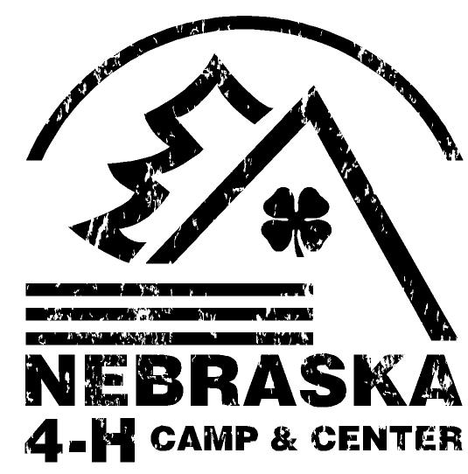
Adventure Day at 4-H Camp
Day Camp
Camper Information Packet
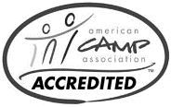
Important information enclosed.
Please read the entirety of this packet.
Welcome!
We are excited for your camper to experience Adventure Day at 4-H Camp! This packet is filled with information to help prepare your family for camp and make your camper’s experience, safe, fun and fulfilling! Camp is a special place, full of opportunities for growth and personal development. Our highest quality of leadership and staff will be provided at all of our camping programs across the state to instill a great sense of appreciation for the outdoor world.
Day Camp is the perfect place for your camper to develop new skills and build self-confidence in a safe, fun environment. Many youth come to camp because they want to have fun, but they leave with so much more! Your child will come home with new friends, bolstered confidence, leadership and outdoor skills, and a lifetime of memories that you made possible - all by giving the gift of camp.

Even if you have been to one of our camps before, please read through this thoroughly as some things may have changed. If you have any questions that are not answered here, please do not hesitate to contact any of the directors listed below.

Sean Gundersen Katie Zabel Kali Tomlinson
Camp Director Camp Program Coordinator Camp Program Coordinator
sgundersen2@unl.edu kzabel2@unl.edu ktomlinson2@unl.edu

Directions to Camp
From the north, east and west: Take I-80 Exit 432 then Highway 31 south 5 miles to the Center. From the south: Highway 50 north from Louisville across the Platte River. Turn left on Highway 31 and go 6 miles to the Center. Note: Our driveway is separate from the Aksarben Aquarium.

Camp Forms & Check In/Out Information
REQUIRED CAMPER FORMS
At the time of your registration, you were required to complete and sign several forms. Please make sure that you are sending your child with the most up-to-date information on their account. Included in the online paper work was the Camper Health and Permission Form, Medication Log, Nebraska 4-H Youth Code of Conduct Form, and Permission to Treat. You can access to review or edit these forms online via your Ultracamp.com account.
CAMPER CHECK IN & CHECK OUT TIMES
- Check-in takes place each morning from 9:30-10:00 a.m. Arriving between the designated times will allow our staff to give you the attention needed with no disruption to our programs. Once you arrive at the Eastern Nebraska 4-H Center, you will be directed to the Main Lodge where you will drop off your camper. If your child has medication, we will ask you for additional information.
- Check-out will take place at 4:00 p.m.-5:00 p.m. at the Main Lodge. We will have your camper ready at that time. You will need a photo ID to sign out your camper. On the final day of the camp session, camp staff will return any medications left with the Health Supervisor and officially sign out your camper. You will need a photo ID.
ABSENTCES: If your child is sick or unable to attend Day Camp, please call the Eastern Nebraska 4-H Camp by 8:30am at 402-332-4496. We verify absentees, so please contact us in advance.
LEAVING WITH AN ADULT OTHER THAN PARENT/GUARDIAN: If your camper needs to leave with a person other than their parent, please bring a note with the name(s) and number(s) of the approved adults prior to alternate pick up. We will add this person to your authorized pickup form.
Medical, Dietary, & Special Needs
HEALTH/SAFETY: Nebraska 4-H Camps are accredited by the American Camp Association. We strive to maintain high professional standards for the safety and welfare of all campers. We have arranged emergency care. If a camper is injured, if possible, we will contact parents before taking them for treatment. If the camper requires daily medication or special health care, be sure to note this on the medical form or camper information sheet. Bring the medication in its original or prescription packaging to the counselor on duty along with instructions. Campers should not bring a large supply of medicine, only what they will need for the week, to be controlled by staff. Counselors have received First Aid and CPR training. Campers should report all accidents or illness to their camp staff.
MEDICATIONS: To assure the safety of our campers, prescription and non-prescription medications (except asthma inhalers and Epi-pens) will be checked into our camp staff at registration. No medications of any kind (except asthma inhalers and Epi-pens) are allowed in the cabins.
- Please leave all prescription medications in the original container with the official prescription label with only enough medication for your camp session. For your child’s safety, we will not be able to accept any medication which is not in the original bottle with the official directions or prescription label.
  - Please place all prescription and non-prescription medications in one zip-lock bag. Write your child’s full name with a permanent marker on the bag.

SIGNIFICANT ILLNESS OR ACCIDENT: I n the event of a significant illness, injury or if professional medical care is sought, parents will be notified by camp staff. Summer staff have been trained and certified in the use of CPR and First Aid. Please be aware of the risk associated with outdoor activities and be assured we have taken every reasonable precaution. The safety and well-being of your child is our highest priority!

MEALS: Our camp menu offers a variety of different, delicious, well balanced meal. We serve the majority of our meals in our Dining Hall in Cafeteria Style.

SPECIAL DIETARY NEEDS: If your child requires special dietary needs please make sure to note that in the appropriate section on the registration form. We can accommodate most common allergies including peanuts, tree nuts, dairy, and gluten. You may also bring your own food that we can individually prepare for your child at each meal. Please call the office with any questions. We are a Peanut and Tree Nut Free Facility!

Day Camp Program
Each day will include a variety of games, crafts and educational sessions. Other portions of the day will vary according to the theme and weather, and may include speakers, tours, and other special activities. We will inform parents of special activities requiring special dress or equipment.
CAMPER GROUPS: Campers will be divided into groups appropriate to their age and activity. Camps commonly use “buddy” systems in camp settings, e.g. swimming.
RULES: Camps have specific rules related to their programming, location and activities. Overarching “3 R’s” allow for consistency between camp programs and weeks.
- Respect yourself
- Respect others
- Respect your environment
Campers are expected to follow the 3 R’s and the direction of the camp staff.
Camper Equipment – To Bring or Not to Bring
Campers are responsible for ALL items brought to camp and we suggest parents write camper’s name on the items they bring to Day Camp. Nebraska 4-H will not provide these items.

- Backpack
- Change of clothing
- Closed toe shoes
- Sunscreen
- Bug Spray
- Water bottle
- Seasonally appropriate clothing (we will be going outside)
  - Snow boots
  - Snow pants
  - Winter coats

DO NOT BRING TO CAMP: As you know Camp is a special place. We intentionally try our best to setup the right camp atmosphere. The following items detract from this atmosphere and the spirit of camp. Please help us provide the best possible experience by ensuring these items are left at home:
    - Firearms – includes BB and pellet guns
    - Fireworks

If above items are found in camp, parents will be called immediately and the camper will be sent home.
    - Cell phones, radios, headsets, CD players, I-pods, etc.
    - Electronic games
    - Knives and multi-tools
    - Lighters/matches
    - Expensive jewelry, watches, other valuables
    - Personal sporting equipment including Archery Bows, BB guns, etc.

These items will be confiscated until the camp session is over. They will be returned to the parent/guardian picking the camper up on checkout day.

Other Important Information

INCLIMATE WEATHER: Day Camp will be held in inclimate weather unless dangerous to participants or staff. Camps have access to shelters and buildings to utilize throughout the program day. All programming is weather dependent, including swimming, field trips, activities etc.
LOST AND FOUND: Please be sure to label everything you send to camp with your child’s name. With so many children at camp, we cannot be responsible for possessions which are lost or left at camp. Please check the Lost and Found table before leaving camp. Items not claimed at the end of the summer will be taken to Goodwill.

CANCELLATION: All cancellations are subject to a $25 processing fee. No fees will be returned if the camp being attended is not notified 14 days prior to the camp session commencing. Nebraska 4-H reserves the right to cancel any program and will provide a full refund.

CHANGING CAMPS: I f for some reason you wish to register for a different camp, the request must be made at least two weeks prior to the camp for which you originally registered. Changes will be made only when feasible. There is no charge for changing camp sessions.
NEBRASKA 4-H DISIPLINE AND BEHAVIOR POLICY: Nebraska 4-H is interested in the welfare of all children. Participants in Nebraska 4-H programs are expected to follow the rules of the program and obey the direction of the staff. A child’s failure to and inability to follow rules or obey directions may cause a serious discipline problem. A serious disciplinary problem is defined as one in which a child is hampering the delivery of the camp program by requiring increased one-on-one attention; is inflicting physical or emotional harm to themselves or others; is abusing staff or is otherwise unable to conform to the rules and guidelines of Nebraska 4-H and the 4-H Code of Conduct. If a child is not able to adjust behavior or if behavior warrants immediate removal, a dismissal from program may be implemented. Nebraska 4-H reserves the right to dismiss a camper without refund in these instances.

